Benalla and District Inc.

Newsletter –September 2023
U3A Benalla & District Inc  P O Box 674, Benalla 3672  u3aben@gmail.com | President: | Margaret Jenkins  5762 6944
Website: u3abenalla.weebly.com  Facebook: facebook.com/U3abenalla/  Newsletter: newsletter.u3abenalla@gmail.com | Secretary: | Geraldine McCorkell  M: 0408 522 662  gmccorkell@activ8.net.au
Please send reports for the newsletter to newsletter.u3abenalla@gmail.com by 25 September 2023

President’s Report
On Tuesday 22 August I was the guest speaker at the CWA Group Conference held at Swanpool. This group of women came from as far away as Corowa and were really interested to hear about U3A Benalla. There were a variety of questions after my talk which showed how interested they were. Two members of the audience were members of U3A Benalla which also helped with the impact of the talk.
On Wednesday 30 August I am presenting to Councillors at an Assembly of Council briefing regarding U3A Benalla and our need for another meeting room in the near future. Geraldine is also coming to the briefing. Our U3A Benalla membership continues to grow and is currently 394, which is an 18% increase on membership in 2022.
During the past week we have been notified that U3A Benalla has been awarded a Get Online Week grant. This will fund the free lunch we are providing members on Wednesday 18th October at 12 noon. Will Rusin will speak on Cyber Security. Jenny Sawyer and Robyn Lukey, who have run the Be Connected program this year and who run our popular Tech Advice program, will be in attendance. Please come along and enjoy lunch and hear a little about our Digital Technology programs.
Our guest speaker for Meet and Mingle on Wednesday 20th September is the President of the Men’s Shed, Lou Sigmund. Lou will speak about the Men’s Shed and how they will be able to help U3A members and the wider Benalla community. You may remember that Lou gave us a very entertaining Meet and Mingle in June when he spoke on Marketing Inventions.
Currently we are in negotiations with Age Friendly Benalla regarding them setting up their Information Spreadsheet on the computer in our Room 2 for two half days per month. This Information Spreadsheet has been put together by the Benalla Council Aging Well Officer, Chris Greentree, and provides a huge amount of information for older members of the community. It is envisaged that having it available in our building will provide another service not only to U3A members but also to members of the Senior Citizens and other members of the Benalla Community. More information regarding this project next month.
Margaret Jenkins, President

Group Reports

A Taste of Art
A new member of Broken River Painters, Leon Pappas, has offered to take two workshops for U3A members in drawing and painting in September. Leon is an experienced artist of many years who works in acrylic and graphite. The workshops will be held on Wednesday 6th & Wednesday 20th September at 1.30 - 4pm at Barc Hut 11. Any present or new U3A members would be welcome to come along. All materials will be provided. Please let me know on 5762 2373 if you would like to attend.
Carol Perry

Art Appreciation
At our last meeting we listened to local Benalla artists Victoria Cooper and Doug Spowart traverse themes, both personal and political, in the investigation and representation of “site” and “place” in the Australian landscape. Much of this work was created in response to the historical and contemporary changes to our place in the landscape and the philosophical concept of Solastalgia. From this they have created work through artists-in-residences and commissions in places across Eastern Australia including Arthur Boyd’s Bundanon, Muswellbrook, Myall Park Botanic Garden in central southern Queensland and Mildura.
Victoria and Doug take photographs using both conventional and Camera Obscura methods. They produce unusual and artistic books which give an impression of site. They have started to work on Winton Wetlands and we look forward to the results of their endeavours.
Coming up – On Monday September, 4 September, from 10 to 11 am - a presentation by Dr Suzie Fraser, Coordinator at the Centre of Visual Art, University of Melbourne, in conversation with exhibiting artist Jen Valender, about the ‘Art + Ecology’ residency program at Dookie Campus. The presentation coincides with the display of four works resulting from the residency program in the major exhibition Always and Altered.
Neville Gibb

‘As Time Goes By’ – Memoir Writing
Mannequins or telling stories, we are not the retiring type
Our August session began with two spritely but aging mannequins, exhibiting their spectacular upper torso garments, reflecting significant events in their life journey and, the display of one baptismal gown, beautifully designed from a beloved wedding dress. The scene was set for, arguably, one of the most engaging sessions this semester.
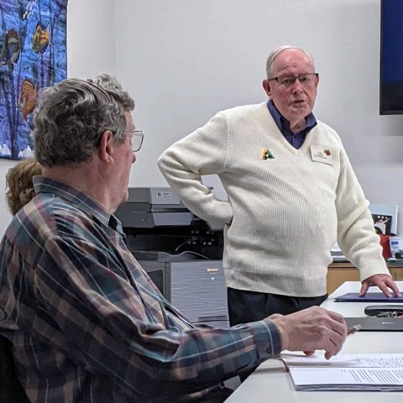 | 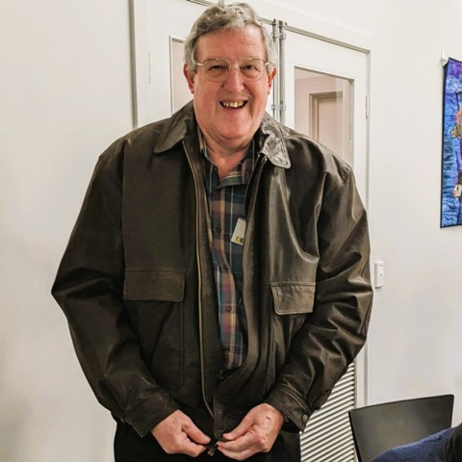 | 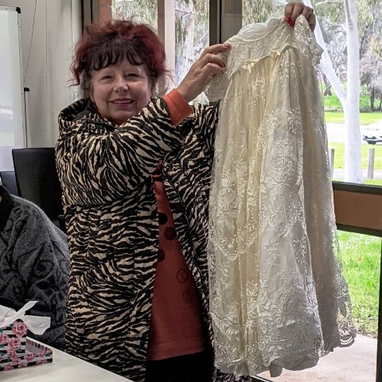
‘Retirement’ was the theme but experienced via individually unique pathways. It was in fact her husband Don’s retirement that encouraged Carmyl to begin teaching Indonesian to local children at her local primary school. James’ forced retirement for health reasons reflected long term planning and a return to a rural retreat, albeit after a cross-Tasman journey. Beverley found ‘retiring’ from nursing a sheer joy but a difficult transition due to staff shortages which delayed finding her ‘time in the sun’. Heather W found the transition challenging as it was not in a manner of her choosing, ultimately though empowering, as a reframe and re-engagement with community became the pathway to personal fulfillment.
By contrast, Lou offered a teaser to future memoirs as he introduced us to the ‘delights’ of a displaced persons camp and a grieving mother who would go to the other side of the world to advantage her children.
Graham reflected on how the death of his Director, soon after retirement, was an incentive to find a healthier lifestyle and Ray delighted us with his post-retirement European and South Pacific pilgrimages.
Heather H, at retirement, would not stay bored for long. Devastated after an unexpected redundancy, volunteering has been energizing and she is yet to define retirement. Barry now asks, how did I ever find time to work? With seventeen community groups in Swanpool, he has been able to access skills and knowledge in service to the community.
Unlike some in the group, Jill had not planned her retirement. COVID denied her this opportunity. As her organisation closed down, so did the community. The ‘ATGB’ members listened, we emotionally walked with her, and are glad she has joined us.
September’s topics: ‘(…..) Adventure’ Share with us your memories of an adventure or two – set the scene, create a sense of the drama involved, and reflect upon the outcome and the meaning of the adventure to you. Or ‘Deja vue’ “Write about a time when you thought ‘It’s happening again’ or realised ‘It happened again’, when you felt a strong feeling of ‘déjà vu’. What was happening at the time? What (who) did it remind you of? Why are these memories significant to you?” Or Member’s Choice A chance to develop your own ‘500 words’ topic and share it with others!
Graham Jensen

Be Connected
During Get Online Week during Seniors Month, we are holding a free lunch for members on Wednesday 18th October at 12 noon. Our speaker on Cyber Security is Will Roisin. Jenny Sawyer and Robyn Lukey, who have run the Be Connected program this year and who run our popular Tech Advice program, will be in attendance. Please come along and enjoy lunch, hear a little about our Digital Technology programs and, rumour has it, be entertained by the Ukes4Fun group in their very first public ‘jamming’ session!
Margaret Jenkins

Bird Watching
Next outing to Killawarra Forest Thursday 14th September
Spring is nearly here and the wattles are looking wonderful. It’s a lovely time for birdwatching. We start our program for semester 2 on 14th September with a visit to Killawarra forest northwest of Wangaratta. Because of the travel involved, I would like us to meet at 9am, instead of 9.30am, at the carpark at the back of the Seniors Building. Please bring the usual things for outdoor activities – a hat, water, binoculars if you have them and wear sturdy footwear. You may want to bring a sandwich or snack in case we do not get back to Benalla by lunchtime. If you are a passenger, please bring a small amount of money to pay your driver.
Kathy Costello 0447 625 755

Brain Games
Laughter, shared effort, imagination and lateral thinking all come into play when you're doing a neurobic workout.
Elspeth Maconachie

Bushwalking – Easy Walks
August Report: Winton Wetlands
The rain cleared, the sun shone, and twelve enthusiastic walkers met for a hike along the dam wall at the Wetlands. Along a stretch of about 6km return, we noted the brimming Mokoan ponds on one side, and lush crops on the other. Our photographers were busy and we met some birdwatchers doing a count of all the bird life attracted to this beautiful area.
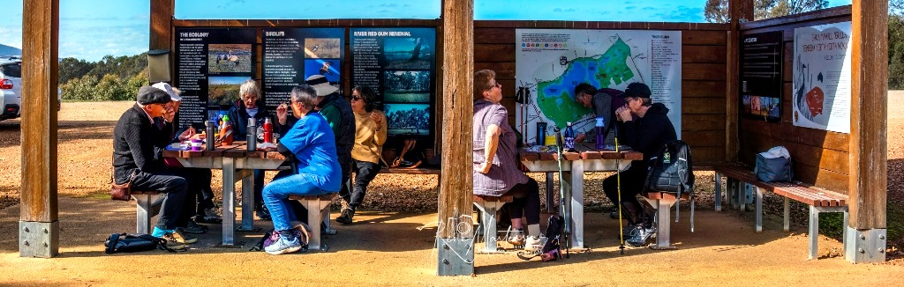
Moving on to Greens Hill, we had a picnic lunch and a shorter walk before adjourning to the Hub Cafe for coffee, finishing off an interesting day.
Wednesday 6th September: Kinnairds’ Wetlands, Numurkah
With over 145 bird species recorded, this walk on the outskirts of Numurkah will take in several short trails through the mostly red gum forest which is fed by flows from the Muckatah catchment. Stopping initially in Numurkah, we will then drive on to the Wetlands, returning to Numurkah Park for a BYO picnic or takeaway lunch.
Meet at the Seniors’ carpark at 9.30am, with confirmation to Julie by text, email or phone message on 0407823031 or juliemcneill55@gmail.com. Remember drinks and a picnic lunch. Car sharing is usually available for a small contribution.
Wednesday 4th October: Warby Ovens National Park: Friends Track and Wildflowers
This much anticipated walk has been delayed both by bad weather and covid over the past three years, so we will cross fingers for some sunshine. One for the wildflower enthusiasts, we will leave Benalla at 9.30 for Wenhams’ Camp, taking the Friends’ Track with a diversion to Kwat Kwat lookout with views over the Ovens Valley to the alps. The track passes a stand of iconic grass trees, through forested granite hills and spring wildflowers. Lunch will be a BYO picnic at Wenhams’ Camp, meeting details as above at the Seniors’ carpark.
Julie McNeill

Cards ‘500’
Our Cards 500 sessions continue to attract U3A members due in part to the flexibility that two sessions per month allow.
We are proud to say that some of our regulars are aged 93 and 92. What an achievement to be able to play at that age.
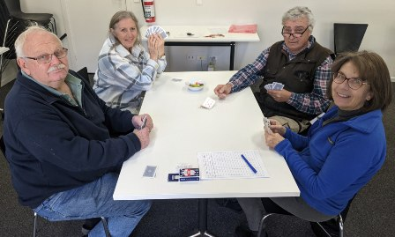 | 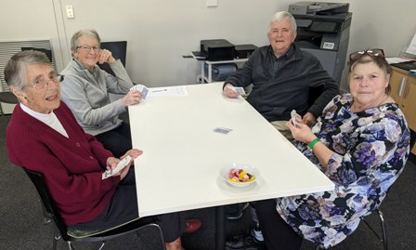
Our sessions are sometimes noisy but with much laughter. A number of the games we play, particularly 5 handed, include calling a partner when finalizing the bid. This has brought into question what rules apply viz. do you have to call a partner and does the bidding have to start at 6 or can you bid at any level? I will clarify the answers to these queries and issue a clarification note.
I have purchased new packs of playing cards that have been well received and are a joy to shuffle and play with. The old cards do seem to get sticky quickly.
Keep shuffling.
Doug Smith

Chat n’ Chew
September’s Chat and Chew will be at the North Eastern Hotel commencing at 12 o’clock. Please ring Lorraine on 0427376991 if you will be attending. If I am unavailable to answer the phone, please leave your name and phone number and I will ring you back. Thank you.
Lorraine Knox

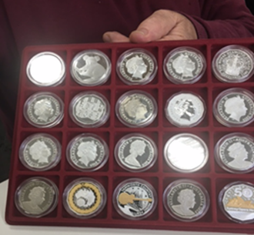
Coin Collectors
Our regular group of six coin collectors were presented with a real challenge with the August Coin of the Month being the most attractive non-circular coin.
Most coins are circular because of ease of production and their shape does not wear holes in clothes pockets. The most common non-circular coin we are familiar with is the Australian 50 cent piece which has 12 sides and called a dodecagon.
We were presented by one of our members with a beautiful collection of silver and gold 50 cent coins (see photo), most of which none of us have ever seem; what a treat! (Bottom, second from the left, ‘The Winner!’)
We were also presented with a number of other non-circular coins including a 7-sided 50 cent piece (heptagon), a 12 sided three pence from the UK and a Hong Kong 12 point scalloped 20 cent piece.
Most of our modern circulating coins are round because a round shape is less likely to wear down unevenly since no one part of it sticks out further than the rest from any angle.
Also, in the days when coin value was assessed by metal type and weight, it was easy to cut off the corners but more difficult to do that with round coins. Milling of the coin edges also limited this practice especially when coins were made of precious metals like gold and silver. Then in the modern world there were vending machines which need coins to roll.
Coin of the Month for September will be “let’s talk about the Australian penny and its dots”.
Doug Smith

Collectors
It’s time to head out to the shed to find a collectable item or items from the past!
Collectors will be returning on Monday 4th September at 10 am revisiting a previous topic: “Something from The Shed”. All welcome.
Janet Gourley
Community Singing
August 2023 has five Thursdays, and we were fortunate that Brian Greed offered to have Community Singing on both the fourth and fifth Thursdays of August. We really do appreciate having Singing available each Thursday Brian.
For the fourth Thursday Brian started with our regular Song Book 1, which contains a number of varied Community songs. After morning tea this was followed by Sammy’s Song Book Number 1 which has a different group of well-known songs including Waltzing Matilda and Loch Lomond.
Everyone had a great morning, and it was good to see members coming up to Brian at the end of the session and thanking him for an enjoyable morning.
Margaret Jenkins

Creative Writing
More stories, more laughs and more hints as to how to improve our writing.
Hints/Challenge:
During the class last month there was a brief discussion about the use of ‘colon; vs ‘semi-colon. So, this month we had a session and challenge about the different uses of these two items of punctuation.
Our stories: The prompts for August were:
- The swans bobbed up and down at the edge of the lake.
- It was the summer when the chickens went on strike.
- That part of the city always brought back memories.
Prompts: The prompts for our September class are:
- She waved cheerfully as the boat gathered speed and disappeared around the bend.
- The wavelets washed over the sand and, in retreating, uncovered a shiny object still half buried on the desolate beach.
- He was lurking behind the bins OR He was found slumped behind the bins.
Joy Shirley

Demystifying Psychology - Course
In August Session 2 we completed our focus on key psychological concepts, highlighting the role of codes of conduct and the disciplinary requirements that underpin sound psychological activities. We then discussed:
- Pre and post measurement results (slide 19) show how well a goal has been achieved. In this case the Convenor looked for evidence that individuals gained a basic understanding of common psychological concepts.
- The video of history of (un)ethical psychological research (slide 27) describes the three most important elements of sound psychological research - (1) informed consent, (2) "do no Harm", and (3) making sure subjects are not exploited, ie. justice. Unfortunately, these elements were not always followed when Psychology was emerging as a concept. The video describes some interesting research examples that do not reflect today's ethical standards.
- Understanding your own and others' Preferred Coping Styles (slide 34) can be a huge help in managing relationships and focusing on individual and group strengths. We discussed how a personal quality could be both a help and a hindrance in relationships. For example, standing in front of 300 conference attendees to report on a team's project outcomes requires particular coping styles, including confidence. However, at a team meeting those skills might not be appreciated if that person continues to command attention in a different setting, that is, a meeting room. Likewise, when the same team is working to a deadline to submit the conference paper, the preferred coping style most likely to achieve this is a task specific and focused attention to completing the paper. That same focus in a relaxed social setting may well be viewed differently.
In session 3 we will consider that perennial USA leader, Donald Trump - his childhood influencers, leadership style, expressed values, and, because a leader needs followers, "Trump follower" profiles (USA data).
Next meeting: 19 September 10-12 noon @ U3A Room 1 Seniors Building in Fawckner Street.
Jane Rushworth

Demystifying Psychology - Discussion Group
Benalla's winter migration and trend means a smaller group and additional time for individual input. While we miss our traveller friends and look forward to their safe return, we happily declare ourselves "Old, Bold ... and surviving the cold!".
We meet at Ruby Blue (thank you RB Team!!) 2-4pm on the 3rd Thursday of the month. The content is unplanned (* see below) and a topic grows out of the initial 15 minutes of chat. This month's topic was "leadership" including:
- Leadership/Management styles - generally.
- Experiences working in effective and ineffective management environments.
- Preferred coping styles.
- Public characteristics of some high-profile leaders.
- Effective community leadership.
- Types of leadership, for example, situational and elected.
* There is always a "starter" sitting in the wings as a discussion prompt. This was the (unrequired) conversation starter for August …enjoy.
https://www.psychologytoday.com/au/blog/fulfillment-any-age/201304/top-10-list-psychology-s-big-questions-and-the-answers
Next Meeting: Thursday 21 September 2-3:45 pm @ Ruby Blue Cafe, Nunn Street, Benalla
Jane Rushworth

Exercises for Fun
Exercises for Fun returns after a short break on Monday 4th September at 9.30 am in the Auditorium.
Helen Jeffree

Exploring the Universe
The Search for Dark Matter in the Universe. August 2023
Amazingly, everything scientists know and have observed about the Universe is calculated to be only around 5% of the Cosmos! How can this be? The rest is comprised of mysterious transparent Dark Matter and Dark Energy. As important features of the cosmic web, they control and dictate the evolution of the Universe. Yet, dark matter interacts with nothing we can see or understand, its gravity deflects light and warps time and space, and passes though light and matter like ghostly particles.
Franz Zwicky was a brilliant astronomer. In 1933 he challenged the general assumption that the mass of the Universe consists mostly of stars. In observing the Coma Cluster of galaxies, he calculated that the mass of the cluster far exceeded the calculated mass of its luminous stars. He found that the cluster contained an enormous quantity of unseen matter with enough gravity to keep the rotating galaxies from flying apart. It had no interaction with the electromagnetic spectrum. It does not visibly reflect, radiate or absorb light. He called it ‘Dark Matter,’ matter that cannot be seen.
These scientific observations were continued by astronomer Vera Reuben in the 1960’s. Now we know that nearly all galaxies seem to contain a small amount of compact visible matter located in the centre of a large halo of transparent dark matter. This halo has an immense mass to hold the stars in their orbits.
We watched videos from the New Scientist Academy with Professors Dan Hooper of Arizona University and Chamkaur Ghag of University College London. We learnt of the many ways that the mass of dark matter has been detected, the theories that have been investigated, the sensitive tests that have as yet not produced results. Perhaps we will never know what it actually is but we owe the stability of the Universe and therefore our own lives to it.
The Euclid Space Telescope will examine 10 billion years of cosmic history. It will map the sky in 3D to discover the “Dark Universe”. https://www.youtube.com/watch?v=KhgsMPeVqoY
We finished the session with some more wondrous images and their scientific descriptions from the James Webb Space Telescope. These included Herbig Haro 46/4 https://www.youtube.com/watch?v=eNh2vbL9Z50 and the El Gordo Cluster https://www.youtube.com/watch?v=KSNRXoHxg7Q
References: New Scientist Academy, Harvard Smithsonian, American Museum of Natural History, NASA, European Space Agency.
Bev Morton

Family Research – Beginners/Drop In
DNA questions featured this month after members had been contacted by cousins – ‘2nd to 6th removed’. Robyn discovered that DNA links can’t be confirmed on a tree for distant cousins if the shared common ancestor is ‘further back’ than ancestors currently listed on the tree.
Questions were raised about what the term 'cM' means in the DNA results description, also about the strength of a '23cM' result. We found that cM means 'centiMorgans' and went on to watch videos and view a chart which helped us to understand cM results for different relatives.
Time was spent researching ancestors likely to have featured in British newspapers using Judy’s account with the State Library of Victoria. At our second Drop-In session Phil, now with his own SLV account, was thrilled to locate an article mentioning a forebear’s alleged murder (query suicide) —his dilemma, would the information in the article be worth paying a subscription for!
Margaret also faced a dilemma – should she ask for closed files on a deceased uncle’s war records to be opened? Assisted to discover his service record on recent trip to the National Archives in Canberra, Margaret noticed closed files which may relate to a family mystery concerning her uncle. His file also mentioned he was attached to an 'Intell' unit... what did this mean? An article in a local newspaper discovered using Trove contained possible clues! We added the weblink of his record to his ancestry.com profile - Deb has since prepared a useful handout covering opening war service records and adding them as a weblinks to profiles.
Two fascinating 'inquiry based' Drop-In sessions with all contributing to following up learning needs and managing research dilemmas. Thank you to Judy Barry and Deb Saunders, our wonderful mentors! (Judy is mentoring on the ‘first Thursday’, Deb is mentoring on the ‘second Thursday’, from 2 to 4pm.)
Bev Lee
Family Research--Intermediate
A 'small is beautiful' session - life sometimes gets in the way of working on Family Research!
Helen brought along a typed timeline based a handwritten timeline her mother had written detailing her working life with the WAAF in England, along with a photo of a church in which an ancestor had been warden, with a name and place reminiscent of 'Midsummer Murders'. Helen has now produced thoughtfully organised display folders for each of her grandparent's 'lines', also prepared in duplicate as presents for family members.
Mary reported success in finding documents about her GG Grandfather on the National Library of Ireland website. The destruction of many records in the Irish collection and the fact that some ship's captains recorded the number, not names, of passengers in steerage continue to frustrate her.
After researching for many years, Mary has prepared a detailed family tree chart for family members. What next? We talked about how the personalities who stand out and themes which begin to emerge during our research can provide a fertile basis for storytelling. Mary thought titles such as ‘Grandmother never forgave her’ and ‘She left her mark’ and themes of 'Religion' and 'Class' could provide a place for her to start.
A highlight of the session was discovering information about Helen’s mother's biological father “BL” by checking DNA matches using 'Thrulines' from Helen's DNA test. While we found no shared DNA results from direct descendants of “BL”, we found a direct descendant on his brother “DL’s” line who shares 183 cM (Centimorgans) of DNA with Helen – a first cousin twice removed. Helen is pausing before making contact!
Bev Lee
Family Research – Advanced
Resource sharing this month included useful handouts by Judy Barry on ‘Researching your Family Home’ and Deb Saunders on ‘Adding a Website Link to a Person’s Profile on ancestry.com’ along with a thought-provoking chart–‘DNA - how many centimorgans do you share with relatives’.
Our segment on publishing our work included Andi's latest Gawn to Town column on page 8 of the Tatong Tattler, a delightful account of the story behind a recent gift of a wine cutting originating from the Kangaroo Ground property of her great great grandfather.
For this month's story topic 'Correspondence', Barry spoke about a document containing a detailed record of part of his great grandmother’s family history shared with him by a cousin also working on their family history. How rare and valuable to be able to access an original source describing key information about each of a family of 15 siblings! Andi read a translated version of fascinating family letter dated 11 July 1852 which had been written across then down the writing paper, a scarce commodity at the time.
Dawn reported making good progress on this year’s project of working on her own family tree and has now produced and shared My Heritage genealogical reports with family. Dawn's ‘piece de resistance’ was the screening from her iPad via Apple TV of two videos she has created using an Al program from My Heritage. The program animated a photo of, first her father, then a great aunt, drawing on data from Dawn’s family tree– it was quite disarming hearing them talking about their lives in the 1st person!
September’s topics - ‘Setting the Record Straight’ Share a story about a time when you felt you needed to 'set the record straight' about an element of your family story - perhaps to your family, perhaps to a wider audience eg. community; family history community such as ancestry.com; OR ‘Family Mystery – the Case of the …..’ ‘There is usually more than one mystery in a family tree! Tell us about a family mystery that still, or for a long time remained, unresolved, on your family tree...’.
Bev Lee

Film Discussion Group
Our August class discussed “Sweet As”. This is the story of four teenagers, two indigenous, two non-indigenous, all with problems, on a road trip. They are encouraged to take photos as part of seeing the world around them. Murra is indigenous with an alcoholic mother; Sean has attempted to take his own life; Elvis was attacked on his way home and has problems leaving his community; and Kylie is under the influence of an older man. During the road trip they all find themselves and learn the value of friendship.
This was an extremely good film. The characters are all different, and the performances of the teenagers excellent. Murra (Shantae Barnes-Cowan) showed her thoughts and emotions by facial and body language. There were a couple of lighter and humorous moments which helped lift the film from becoming depressing.
The cinematography was outstanding, providing various views of the Pilbara region of North-western Australia.
Overall, a beautiful film, which was sad in parts but is full of hope. Rating: 4/5.
Other films watched included:
“Red, White and Brass”, based on a true event. Young people in the Tongan community in New Zealand form a marching band to get seats for a world cup rugby match. This was a bit of fun with lots of good music. Rating: 3.5/5.
“The Unlikely Pilgrimage of Harold Fry” was enjoyed by members of the class, with good characterisation. It had a good message about the importance of communication after a family tragedy. Rating: 3.5/5.
“The Last Daughter” is a documentary about Brenda Matthews. She had been fostered with a white family before being returned to her indigenous family. It was eye-opening and emotional, but left Brenda with unanswered questions. Rating: 4/5
“No Hard Feelings”, a predictable and silly film about a girl employed by parents to seduce a 19-year-old before going to university. Rated as 3/5
“Maybe I Do” is about a couple who are at a crossroads – she believes their relationship will grow if they marry; he fears the relationship will fail. It is fun and predictable with good performances by Susan Sarandon and William Macy. Rating: 3/5
“Indiana Jones and the Dial of Destiny”, the final of the Indiana Jones films. It included the traditional amazing chases, with less action than in previous films. Rating: 3.5/5
Our film for discussion on 13 September is a choice between “Chevalier” and “Barbie”.
Joy Shirley

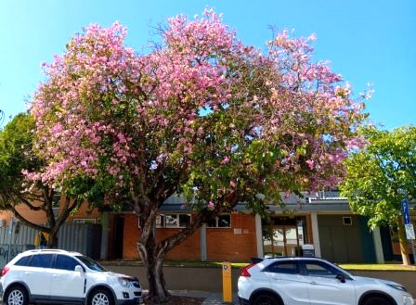
Garden Appreciation
On September 28th we will be visiting Sophie Arendt’s beautiful garden in Hagenauer Lane, Benalla (off Witt Street). Sophie has offered to supply morning tea, then we travel to Sandra’s Nursery in Witt St, Benalla. Lunch will be at the Benalla Golf Club.
Please let me know if you are attending. We will be meeting at the U3A car park at 9.30am.
I am writing this notice of our next activity from Caloundra, at the Sunshine Coast 🌞
The street tree in the photo is called Bauhinid.
Cheers to you all.
Gwen 0438 627 010

Garden Team
In late July the team gardened at James' place, where unwanted plants were replaced. The section certainly looked spruce after treatment.
In August it was Marcus and Kirstin's garden. What a delightful afternoon - lots achieved, beautiful weather, a sumptuous repast and conversation with lovely people.
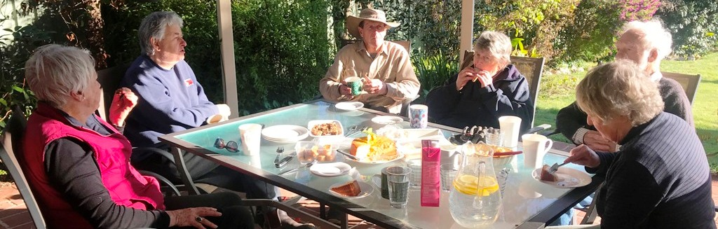
Elspeth Maconachie

German
German class members have increased their vocabulary substantially. It is being put to good use in both reading and writing. Writing gives me insight into where they need to fill gaps in their knowledge of grammar.
Throughout the year it has been obvious how keen the members are to learn, so it is a pleasure to find the right lesson and share my knowledge with them.
Tuesday 12th September will be a day off for the class because my daughters are taking me on a trip to Western Australia. However, I will leave class members plenty to read!
Horst Gunther

Jane Austen Book Club
Our film of Jane Austen's novel Emma was a well-produced British version worth watching as it summarises the love triangles of this group of middle-class country residents. No minor nobility in this novel - the rich arrivistes are here occupying some of the large old estates and concerned about potential marriage partners.
The action is muddied by 17-year-old Emma, who fancies herself as a matchmaker and gets all her attempted matches wrong due to her juvenile attitude and self-centred ways.
Emma dissuades Harriet Smith from marrying Robert Martin, a successful farmer but "not a gentleman" and instead tries to match her with the local parson, who wants to marry Emma - or any woman with a large dowry. Emma falls for Frank Churchill, a wealthy young man under the thumb of his rich aunt. He is secretly engaged to Jane Fairfax, a talented musician and young lady without a dowry of whom his aunt would disapprove. After being rebuffed by Churchill, Emma finally falls for Mt Knightly, a rich landowner in the district who has known Emma since she was a baby, is around 20 years her senior and throughout the novel tries to give her advice about how she should behave in a more mature way.
Eventually Harriet, Emma and Jane marry their appropriate partners.
Witty dialogue, gorgeous costumes and historical settings make this film a pleasure to watch.
Next session: We will watch films of one of the last of Austen’s books, Northanger Abbey, on Tuesday 12th September at 2pm. An excellent British production of under 2 hours length, it will fit into one session. **Anyone who is not enrolled in the course is also invited to join us to watch Northanger Abbey on the big screen in the U3A room.**
Meg Dillon

In the Lap of the Gods
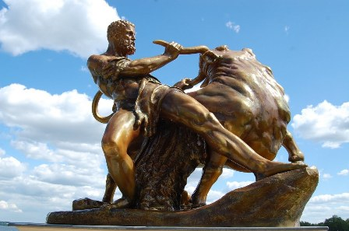
This month saw us review the twelve tasks of Heracles (also known as Hercules) imposed on him as a result of his killing his wife and children. He had killed them in a madness sent by Hera, because Zeus, her husband, had seduced Heracles’ mother. Hera, the ever-rational goddess, over and over sought to kill Heracles for Hera’s husband’s frailties. This madness was yet another punishment sent by Hera to bedevil Heracles.
The successful completion of these tasks and his many other adventures made Heracles the greatest of all heroes.
He was eventually brought undone by his second wife Deianira who foolishly believed the dying words of a centaur killed by Heracles:
‘My blood, mixed with a little olive oil and smeared on your husband’s clothing, will keep him faithful.’
Well, it was true – sort of. Deianira means ‘man destroyer’ in Greek so her name gives away the ending.
Then we looked at Aeneas, a minor Trojan prince who appears in ‘The Iliad’ and who had escaped from the flames of burning Troy carrying his crippled father. Virgil took this character from ‘The Iliad’ and built a literary hero who had his own epic adventures in ‘The Aeneid’. In this literary propaganda work, Aeneas became the true founder of Rome long before Romulus and Remus. Through it, Virgil burnished the grubby and dubious credentials of Octavianus (later to be the Emperor Augustus) and prophesised that Rome’s destiny was to rule the world under the rule of Augustus and his successors. Virgil also explained the causes of the wars between Rome and Carthage (the three Punic Wars). It was not because of economic competition. No, it was because of a love affair in which Dido, the Queen of Carthage, was jilted by Aeneas.
Finally, we travelled with Jason and a stellar cast of heroes aboard the Argonaut to recover the golden fleece at Colchis. After adventures and battles, Jason and his heroes returned with the golden fleece and Medea, princess of Colchis and an accomplished sorceress. When Jason later threw her over for Creusa, princess of Corinth, Medea killed her two children by Jason, killed Creusa and her father and then fled to Athens.
One of the most intriguing female characters in Greek mythology, Medea left a trail of death in her wake wherever she went, starting with her brother whom she cut in pieces to force her father to slow down in pursuit and pick up the bits. Thus, the Argonauts (and Medea) escaped Colchis.
Unlike all other characters, male or female, in Greek mythology, Medea was never punished for her murders by the gods. Indeed, she retained their favour throughout her life, as demonstrated by their aid and support of her.
Next time, I intend to review how a Greek or Roman believed that he or she could live a good life and how this changed over time.
John Barry

Investment
Both Malcolm and John were away on holidays, so Margaret and Les ran the August session of Investment.
We started with the Monthly and Long-Term selections and talked about the sideways movement in the market which has been happening for the past three months.
We then moved on to discuss the ASX Indexes for the End of Financial year 2022-2023 and noted that the ASX Midcap index had performed slightly better than several of the other indexes.
Looking at the ASX Sectors for the End of Financial year 2022-2023 there was a much wider range of performance. The Information Technology sector returned a gain of over 30% whereas the Materials and Resources Sectors showed a gain of 17%. At the other end of the scale the Health Care and Consumer Staples Sectors returned less than 5%. We also looked at charts of Information Technology and Materials shares.
On a slightly lighter note, we looked at what happens from 4pm to 4.11pm on the ASX. This informative piece came from Market Index on 23 July 2023, and included information about the Closing Single Price Auction which serves several key functions in the market.
After afternoon tea, Les spoke about Investment Opportunities with Net Zero in 2050. This presentation included charts showing where Uranium is mined and used in energy production around the world. The rising world price for uranium causing reopening of mines in Australia was shown. We saw charts showing the surprising decline in prices for critical metals used by renewables last financial year and this financial year. This implied lack of demand and increased supply by new market entrants, as forecast by The World Bank.
Margaret Jenkins & Les Rodgers

Let’s Talk Books
We were delighted to have Patsy recite a poem to us about Jim who was eaten by a lion, you could hear a pin drop during her recitation and a round of applause followed, thank you Patsy, you add another dimension to our group.
Books read this month were The Dry by Jane Harper, enjoyed the book not the movie. The Goldminers Sister by Alison Stuart, Alison recently appeared at the Benalla Library for an author’s talk. Twilight of a Goddess by Christopher Nicole, the romantic adventures of a notorious woman in 1835!! One of our readers has had a busy time with crime novels, her reads were A Time for Mercy by John Grisham, River Sing Me Home by Eleanor Shearer, Catching Air by Sarah Pekkenan, Deadly Cross by James Patterson, I Will Find You by Harlan Cobden, and last but not least The Dolls House by M. Arlidge. Shirley enjoyed Anzac Girls by Peter Rees the heroic nurses who served in the Great War, A Pocket Full of Happiness by Richard E Grant, lovely read but sad. Recommended are books by John Douglas, a criminal profiler with the FBI, who maintains people are not born murderers they choose to be. Troy by Stephen Fry was disappointing and not finished. Montsalvat the story of the artistic colony set up by Edmund Jorgensen was a look at history of this beautiful area. Wilding by Isabella Tree, is the story of the `Knebb’ experiment, rewilding a farm in West Sussex, this book is very popular. The Whole Day Through by Patrick Gale a beautifully written novel and thoroughly recommended. Rough Justice by Robin Bowles unanswered questions from the Australian Courts, raises questions and doubts along the way. The Australian Lighthorse by Roland Perry recounts the bravery of this group in Arabia during World War 1, worth reading. Isabelle Allende wrote Of Light and Shadows, her usual good work and The Unbelievable by Vikki Pentrastis, a well written first novel. The Grandest Bookshop in the World by Amelia Mellor, 1893 in Coles Book Arcade in Melbourne mysterious adventures happen, well worth reading. Cautionary Tales for Young Children by Hilaire Belloc written nearly a century ago, contain 7 stories
Geraldine McCorkell

Lifeball
We’ll be back on court after our winter recess, on Monday 4th September at 10am. We play weekly at the Benalla Indoor Recreation Centre, in a game of modified basketball-lots of laughs and no experience needed, and we always conclude with coffee and a chat. New players are always welcome, and convenor Marlene can be contacted on 0428210944 for more information.
Julie McNeill

Meet and Mingle
Alex McKenna, CEO of Cooinda in Benalla, was the Guest Speaker at our August Meet and Mingle. Alex spoke about the new buildings which are being constructed at Cooinda in 2023-2024.
The first stage is a new kitchen and staff room which is due for completion at the end of October 2023. This will be followed by the construction of several new larger units which will provide more up to date accommodation than what is currently available This part of the redevelopment will also have a “main street” which will include a hairdresser, coffee shop and an open-air area.
There are also several areas which will be landscaped. A feature of some of the paved road surfaces is that their surface will be permeable to water. There will also be several more parking bays in the new plans than what is currently available.
Cooinda is an important part of the Benalla community. Alex illustrated his talk with suitable slides. This is a substantial redevelopment, with the total cost of the redevelopment being about $8 million dollars. Thank you, Alex for a great talk.
Our Guest Speaker for September Meet and Mingle on Wednesday 20th September at 10am is Lou Sigmund, President of the Benalla Men’s Shed. Lou will speak about the Men’s Shed and how their members could assist U3A members in the future. Hope to see you all there.
Margaret Jenkins

Music Appreciation
Self-portraits come in a variety of forms. Some are with a paintbrush, some with a camera, others with a pen. It would seem only right - and natural, even - that a musician would choose music. Which is what Camille Saint-Saens is said to have done in his 3rd Symphony. Within its walls are aspects of the composer – his talents, his doubts, his belief, his fears and his hopes. All his instruments are there – a pipe organ (has was a church organist at one time), the piano (which he had played since childhood), his passion for sacred music, the love of logic and balance (there are two movements each with two sections), the forces of darkness (the Deus Irae haunts the work) and finally there is the element of hope as the symphony gradually progresses from darkness to light. Some say it is expressive of his hope of resurrection, although it is well documented that Saint-Saens was not at all religious. Perhaps his aim was to demonstrate the spiritual power of music. Whatever, it was the standout work we looked at in our August sessions.
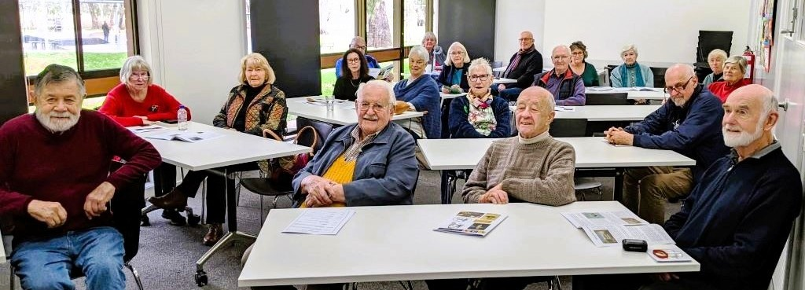Beethoven’s 4th piano concerto, which we also heard, deserves more acclaim than it gets. It tends to be overlooked - coming as it does between the monumental 3rd and 5th concertos - so two totally different recordings were viewed. Love is often in the air when music is being composed and Brahms’ love for Clara Schumann may have inspired his 1st violin sonata, while Mahler’s Adagietto from his 5th symphony was instrumental in the wooing of Anna, his wife to be. These and the ubiquitous overture - every good music programme should start with one – made for happy watching and listening. The video recordings and explanatory notes for each performance can be accessed via the Music Appreciation page on the website.
Finally, a reminder that our class on Friday 22nd September has been rescheduled to Friday 29th September.
Bill Squire

Page Turners Book Group
Recently published in 2022, this novel was well received, especially in America. It details the life stories of two generations of the family of a Caribbean matriarch, her Chinese husband, and their children Benny and Boyd. The idyllic Caribbean lifestyle of the mother is destroyed when she is a young girl who runs away when her dissolute father forces her to marry a local criminal. She changes her name and flees to London, fearing retribution from her husband’s family as he had been poisoned at their wedding. Here she studies nursing and assumes the name of her best friend who was killed in a road accident, still fearing her former husband’s family. Eventually she meets by accident the young man she had wanted to marry and eventually they forge a life together in America.
The novel moves between this narrative and the lives of her two children, her son successful and her daughter, a confused and wayward girl who has lost contact with her mother. The frequent name changes of some characters and the short chapters jumping from the earlier to the later generation creates some confusion. The novel is held together by the trope of the ‘black cake”, a rich fruit cake made with loads of rum. This very cake remained a family favourite, even though a version of it was used to poison the husband at the first wedding.
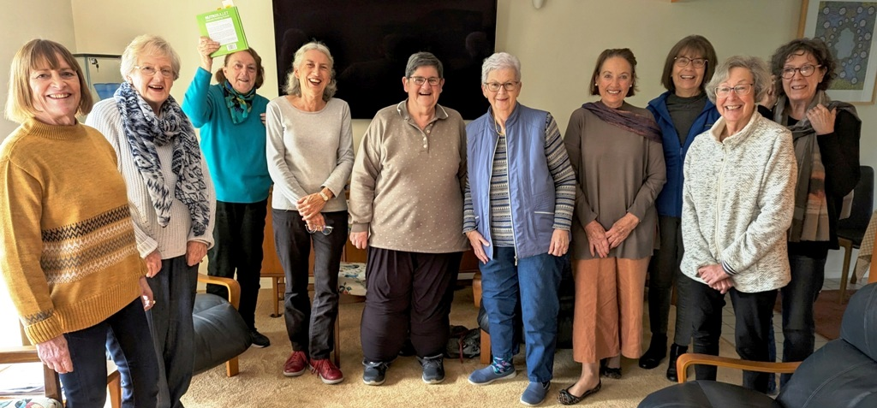
One of our number followed the recipe in the book and made a delicious version of it with loads of Captain Morgan’s Old Jamaican Rum which we all enjoyed with a coffee. It will be my favourite recipe for Christmas Cake from now on!
A lightish read with some interesting insights into Caribbean culture.
Tuesday 5 September: 'Lessons in Chemistry', by Bonnie Garmus.
Meg Dillon

Patchwork and Craft
On Thursday 7th Elaine will be giving us a lesson on Paper Quilling. If you have a Quilling tool please bring it along, paper will be available from Elaine at a cost.
We continue to have lovely work displayed at Show’n’Tell. Keep bringing it along.
Dorothy Webber

Photography
A reminder that Photography classes with recommence on the 28th of September from 10 to 12 in U3A Room 1. I will be sending out an email to class members in a week or so with further information.
Rene Martens

Play Reading
Our play for August was The Prime of Miss Jean Brodie.
This play is based on a novel by Muriel Spark. The script was written by Jay Presson Allen. Jean Brodie is a teacher at an all-girls school in Edinburgh, Scotland, in the 1930s. Brodie is known for her tendency to stray from the school's curriculum, to romanticize fascist leaders like Benito Mussolini and Francisco Franco, and to believe herself to be in the prime of life. Brodie devotes her energy and attention to girls she sees as special or mouldable, who are referred to as the "Brodie Set". At the start of the play, the Brodie Set is composed of four 12-year-old junior schoolgirls: Sandy, Monica, Jenny, and Mary. The play follows them through to their final year. Act 1 covers from 1931 to 1933, Act 2 from 1933 to 1936, and Act 3 in the girls’ final year two and a half years later.
Each act is introduced in the current day with a reporter from the USA has flown to Edinburgh to interview Sister Helena who has had a book published that became a best seller. Then we go to the various scenes involving the schoolgirls and Miss Brodie. We found this an interesting way to set the picture.
After reading the play we discussed some comparison with our June play, Monday Sacrifice. Both plays were set in an all-girls school. The Prime of Miss Jean Brodie focussed on a group of students, but Monday Sacrifice focussed on a group of teachers. They both covered a teacher who recognised the value of the humanities, a culture that still has problems today. There perhaps the similarities ended, with the relationship between Miss Brodie and the schoolgirls the focus of the plot. Miss Brodie had an interesting mind and approach to her students. Whether this was a healthy relationship or not is open to debate.
We enjoyed the play which left us with things to think about.
The play for our next session on Wednesday 6th August from 9.30 to 12 in U3A Room 1 is Brighton Beach Memoirs, by Neil Simon. It does sound good.
Joy Shirley

Recorder Group
The group has been working hard this month in preparation for taking part in a concert on September 10th at Benalla Town Hall. The Benalla Concert Band very kindly offered us a place in their concert, which was terrific of them. Sadly, I have a concert at the same time, but the group has taken it on board and is very keen to go ahead with it. Good on them!
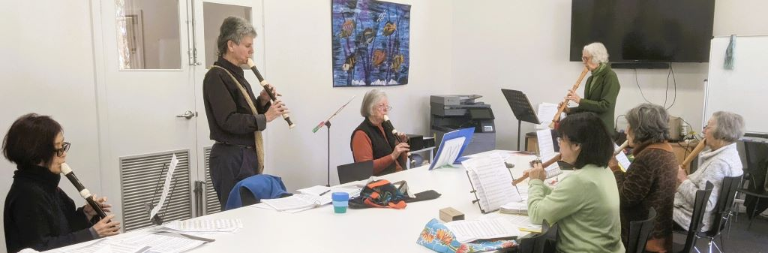
Janet Douglas

Singing for Fun
During August we have had Carmyl involved in two of the mornings due to Margaret being away on holidays. Carmyl chose a group of gospel songs for one of her sessions which was a bit unusual for the group, but they performed the songs very well.
Kieran has this great knack of getting us going each morning, choosing some rousing songs in the process. One morning Kieran included the Battle Hymn of the Republic and everyone sang it with great gusto.
Brian has been revisiting some songs such as Right Said Fred as well as The Black Hills of Dakota which have been enjoyed.
Thank you to Gwen for accompanying all the different songs, with no notice. You do a wonderful job.
Our numbers are remaining close to 30 each morning which is great to see.
The next Singing for Fun meeting will be on Thursday 7th September at 10am at the Hub in Cooinda.
Margaret Jenkins

Sky’s the Limit
This month we visited Precision Airmotive at Wangaratta. This aerospace company restores and makes parts for old airplanes. They specialise in the WW11 era planes. The owners have their own Kittyhawk and also a Mustang. We spent two hours with our guide Lou, who showed us some of the precision machinery they use for the restorations. The restored planes finish up in other parts of the world and also in RAAF museums. On our tour we noticed shelves piled with what looked like junk. Louise explained that they were parts of aircraft that could not be salvaged. Often the original plans they have are not too detailed and they use these oddments to assist in putting things together as the originals were. Some parts cannot be found, and this facility is the only one in the world that can reproduce the pieces the same as the original. As you could imagine deep pockets would be needed to finance the work that is done at this fascinating place.
At the end of our tour those of us who were flexible enough were invited to ascend the wing of the Kittyhawk and peer into the cockpit.
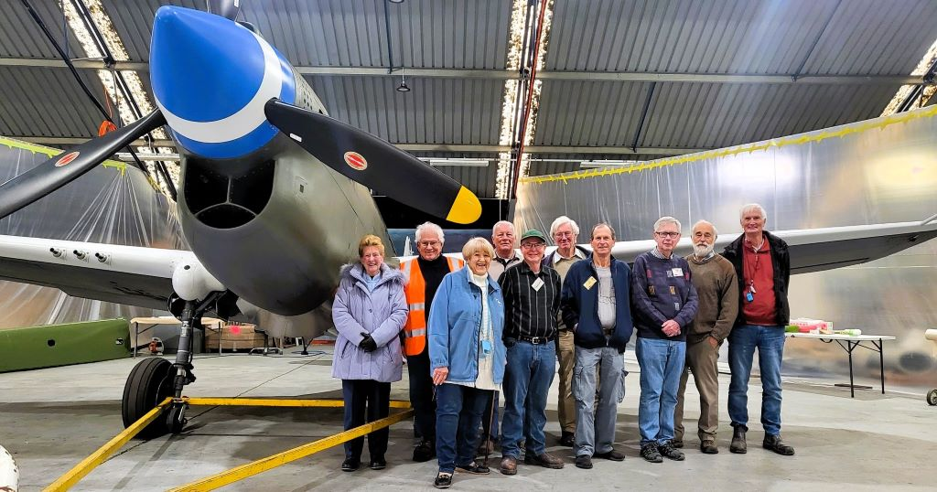Outside the old Wangaratta terminal on the edge of the car park, there is an interesting tower. Originally it was erected above Wangaratta Motors Garage in Reid Street in 1937. The beacon on top of the tower emitted a flashing red light signalling the letters W.G. in Morse code which was used to guide aircraft during night air mail services between Melbourne and Brisbane.
Claire Rudolph

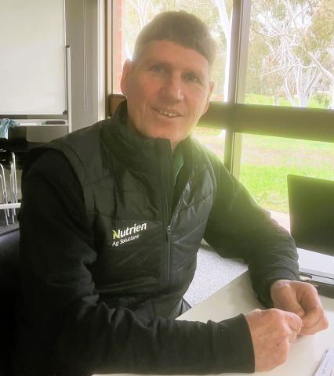
Stock and Land
Luke Marple, a local farmer and manager of stock and station agent Nutrien Harcourts in Benalla, spoke of the current good season, high and low livestock and land prices and the difficulty and ease of doing business during Covid.
Selling lifestyle farms during Covid, Luke would film properties on his phone and forward the result to interested people, mostly city dwellers. They would often respond immediately with a contract request and then almost straightaway send back the completed contract and 10 per cent deposit. His best sale was a 35-acre block of rock which quickly sold for $10,000 an acre.
Luke said the October 2022 flood on his 500-acre Broken River frontage farm, was worse than 1993. But he said one of the major benefits for a sheep producer was the drowning of hundreds of foxes. Unfortunately, all platypuses seemed to drown too.

Our next speaker on Tuesday September 4 will be Dennis O'Connor, principal of Mistletoe Limousin, Greta South. This year marks Dennis's 30th anniversary of breeding Limousin cattle. A highlight of that period has been moving from a predominantly horned stud to one that is predominantly polled.
David Palmer

Sustainability
At our first session in July the Sustainability Group revisited Treasury's new take on measuring how Australia is going; called the Wellbeing budget. This approach is the same as addressing sustainability. The wellbeing budget, as with indicators measuring progress across environmental, social and economic sectors. Only when we achieve sustainability in all three sectors is true sustainability/wellbeing achieved. The wellbeing budget is a first attempt at moving budget measures away from purely the economic elements (usually measured by Gross Domestic product per capita) to establishing measures, targets and policies across the three primary elements mentioned above. This approach still has some way to go in its development but starting down the community wellbeing path is an achievement in itself.
At our second session we had free flowing discussions based on a number of recent articles including one debunking extremist comments that the north Atlantic Gulf Stream (which keeps western Europe warm) will collapse in 2025. Another concerned threats to wildlife which occupy niche habitats in alpine Australia and have nowhere to migrate to in a warming climate and another reporting on a local scheme in the Goulburn Valley to establish a community based solar energy farm and battery.
John Lane

Tech Savvy Beginners – Android
Areas covered during August included:
- Downloading the app browser DuckDuckGo. DuckDuckGo is the Internet privacy company for everyone who’s had enough of hidden online tracking and wants to take back their privacy now. “For over a decade, we’ve built products, created new technology, and worked with policymakers to make online privacy simple and accessible for all. Every day, millions of people rely on our free all-in-one app (Web and App Tracking Protection, Smarter Encryption, Private Search, Email Protection, and more) to stay more private online”. (www.duckduckgo.com)
- Checking our My Gov accounts to make sure that nobody had hacked into our accounts.
- Adding our popular contacts to favourites.
Thanks again to Janice & Ruth for filling in during my absence. See you all 1st & 2nd Thursday of the month from 10 to 12.
Robyn Lukey 0403164931

Tech Talks
The Jet engine is something we all take for granted. We discussed a potential disaster from several years ago when an engine on a Qantas plane blew up and the plane had to land under difficult circumstances in Singapore. This led to Graeme explaining how a jet engine works. Surprisingly a jet engine is a simpler machine than an internal combustion engine. The jet engine was not immediately accepted and indeed the inventor - Frank Whittle - had to let the patent lapse for lack of interest and lack of finance.
We watched a video of a very large plane used by the American Military. This plane is so large it can carry a battalion size of both equipment and service personnel. It is approximately the same size as the Spruce Goose but much more efficient. It can be refuelled in the air and can fly all over the world.
We reviewed a book called Precision Engineering Saved the World. This book is recommended reading.
Neville Gibb
Ukes4Fun
Unfortunately, I have been out of action for most of August, but the Ukulele group have been busy learning new songs and updating their songbooks ready for their upcoming performance at the Meet and Mingle luncheon in October during Seniors Month. We do have some talented people in our group who are able bring the best out in all of us.
Heather Wallace

Wine Appreciation
In August we headed south to the Strathbogie region and Maygar Hills Winery with its spectacular vistas punctuated by rocky granitic outcrops. Our host, Jenny, was so welcoming and gave us a short history of Lieutenant Maygar, the name behind the winery. Lt. Maygar was born on 26 May 1872 at Kilmore. He enlisted in the Victorian Mounted Rifles to fight in the Boer War. He arrived in South Africa in March 1901 and was immediately involved in several heavy actions. In August his column transferred to Natal and was constantly in action against strong Boer commando forces. It was during one of these intense actions that Maygar was awarded his Victoria Cross.
Maygar Hills produces red wines and has won multiple trophies. We tasted the 2018 and 2019 Cabernet Sauvignon and 2019 Reserve Shiraz. Sadly, the vineyard has been sold and so there are limited stocks now available. Lunch was at Seven Creeks Hotel with its good food, friendly atmosphere and open fires.
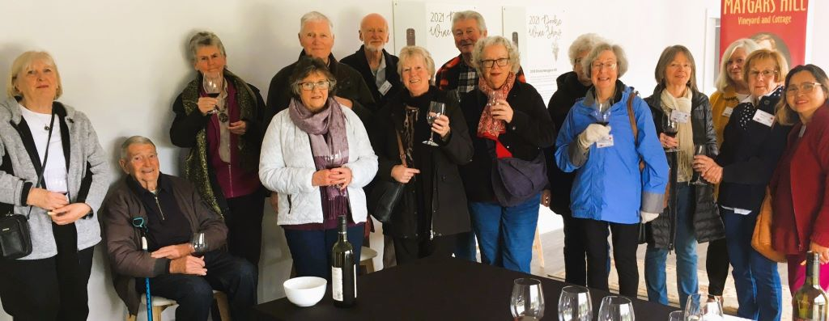
Next month we are off to Gracebrook Winery, 4446 Wangaratta-Whitfield Rd, King Valley followed by lunch at Mountain View Hotel, 4 King Valley Road, Whitfield.
Meeting in the Senior’s Car Park at 1015 and RSVP to me at nicnakmac90@gmail.com or phone/text 0428 696 408 by Sunday 10th September.
Nicole McFarlane

Wise Guys Book Group
At our August session, Neville talked about The Kennedy Curse, “six generations of adultery, addiction and tragedy” by James Patterson. Graham is continuing The Palestine Laboratory. David outlined Horse, a compelling novel by Geraldine Brooks set mostly in the 1850s in Kentucky. Also, Infidelity and Other Affairs by Kate Legge where she traced infidelity in her husband's and her own families through four generations.
New members welcome! Our next session is on Wednesday 27 September from 2 to 4pm in Room 1.
David Palmer
Program News
‘Come and Try’ Taster Sessions during Seniors’ Month in October – Tell Your Friends!
It’s Seniors Month in October, a time when we open our classes to people interested in ‘tasting’ our courses and activities. Timetables with convenor contact numbers can be found on the table outside Room 1 and on the website. People who ‘come and try’ just need to add their name to the roll on the day they attend.
Social Chess Pilot
Congratulations to Doug Smith on having the first meeting of the Chess Group he is trialling on the third Thursday of the month from 10am to 12 noon. Doug is happy to hear from other people who would like to join the group. His phone number is 0417 527 171. It is great to see another U3A group being piloted.

What’s On
Friday, 1 September
10:00 Sustainability
14:00 'In the Lap of the Gods'
Monday, 4 September
09:30 Exercises for Fun
10:00 Collectors - 'Something from the Shed'
10:00 Lifeball - Marlene 0407 240 943
10:00 Art Appreciation – ‘Always and Altered’
12:45 Ukes4Fun
14:00 Investment
14:00 Let's Talk Books
Tuesday, 5 September
10:00 Page Turners - 'Lessons in Chemistry'
10:00 Stock & Land - Mistletoe Limousin
12:15 German
14:00 Sky's the Limit
Wednesday, 6 September
09:30 Easywalks - Kinnairds Wetlands, Numurkah
09:30 Play Reading – ‘Brighton Beach Memoirs’
13:30 ‘A Taste of Art’- Drawing/Painting Workshop
14:00 Cards '500'
Thursday, 7 September
10:00 Singing for Fun
10:00 Tech Savvy Beginners - Android
14:00 Family Research Beginners Drop In
13:00 Patchwork and Craft - Quilling Workshop
Friday, 8 September
10:00 Music Appreciation
12:00 Chat 'n Chew – The North Eastern Hotel
14:00 Armchair History
Monday, 11 September
09:30 Exercises for Fun
10:00 Lifeball - Marlene 0407 240 943
12:45 Ukes4Fun
14:00 Creative Writing
14:00 Garden Team
Tuesday, 12 September
10:00 Politics and Current Affairs
14:00 Jane Austen Book Club- 'Northanger Abbey'
14:00 Tech Talks
Wednesday, 13 September
10:00 Recorder Group
14:00 Film Discussion Group – ‘Chevalier’/’Barbie’
Thursday, 14 September
09:00 Birdwatching – Killawarra Forrest
10:00 Singing for Fun
10:00 Tech Savvy Beginners - Android
14:00 Family Research Beginners Drop In
13:30 Executive Committee Meeting
Friday, 15 September
10:00 Wine Appreciation – Gracebrook Winery
10:00 Sustainability
Monday, 18 September
09:30 Exercises for Fun
10:00 Lifeball - Marlene 0407 240 943
12:45 Ukes4Fun
14:00 As Time Goes By - Memoir Writing
Tuesday, 19 September
10:00 Demystifying Psychology Course – Session 3
12:15 German
14:00 Exploring the Universe
Wednesday, 20 September
10:00 Meet and Mingle - Lou Sigmund, Benalla Men’s Shed
13:30 ‘A Taste of Art’- Painting/Drawing Workshop
14:00 Cards '500'
Thursday, 21 September
10:00 Singing for Fun
10:00 Social Chess
13:00 Family Research - Intermediate
13:00 Patchwork and Craft
14:00 Demystifying Psychology Discussion Group
Friday, 22 September
14:00 Armchair History
Monday, 25 September
09:30 Exercises for Fun
10:00 Lifeball - Marlene 0407 240 943
12:45 Ukes4Fun
13:30 Coin Collectors – ‘The Australian Penny’
17:00 Newsletter reports due today
Tuesday, 26 September
10:00 Politics & Current Affairs
12:15 German
14:00 Brain Games
Wednesday, 27 September
10:00 Recorder Group
14:00 Wise Guys Book Group
Thursday, 28 September
09:30 Garden Appreciation--Sophie Arendt's garden then Sandra's Nursery, Witt Street
10:00 Photography
10:00 Community Singing
14:00 Family Research - Advanced
Friday, 29 September
10:00 Music Appreciation
Monday, 2 October
09:30 Exercises for Fun
10:00 Collectors
10:00 Lifeball - Marlene 0407 240 943
10:00 Art Appreciation
12:45 Ukes4Fun
14:00 Investment
14:00 Let's Talk Books
Tuesday, 3 October
10:00 Page Turners - 'Camille's Bread'
10:00 Stock and Land
12:15 German
14:00 Sky's the Limit
*Tech Advice – one-to-one sessions by appointment for members experiencing problems operating mobiles, tablets or laptops – Contact Robyn (Android Devices) 0403 164 931 or Jenny (Apple Devices) 0409 545 182* Referral on will be suggested if necessary.

