Politics and Current Affairs.

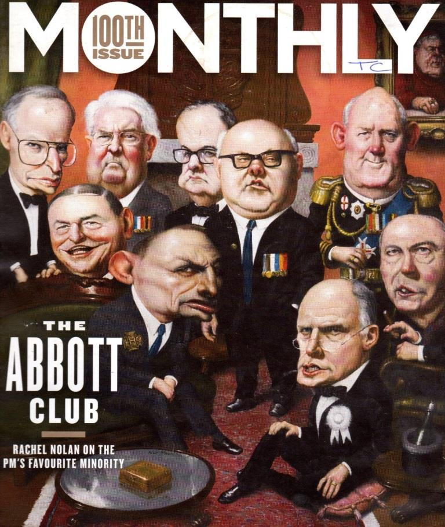
One of my favourite illustrations from 2014 was the Monthly’s portrayal of the Abbot Government as a club for old conservative white men.
The Monthly (available at the Benalla Library) is a good source of current affairs material. I strongly suggest you obtain a copy of the August 2014 edition that tackled the issue of the supermarket duopoly and how suppliers are squeezed and competition stifled.

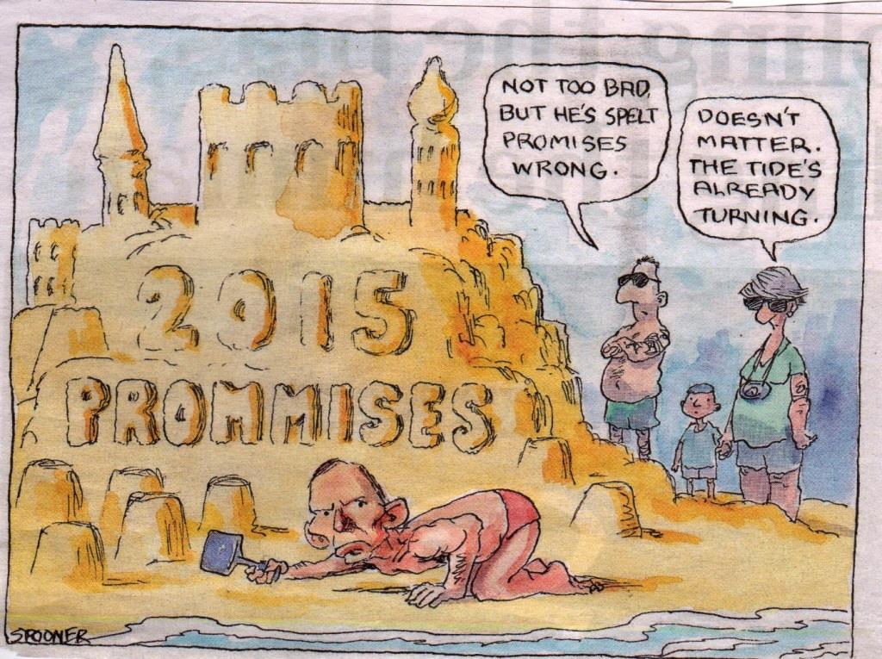
This Spooner cartoon was published in the Age during the summer break. It summed up the growing frustration with the Liberal leadership; two weeks later there were leaks from the Government’s MPs giving vent to their frustration.

Kaye Fallick wrote “Busting myths about baby boomer burdens” published by the Age in January.
Kaye claimed that the government was only focused on what older Australian take in the form of welfare, not on what they give back to society. The article focused on her own mother’s contributions as an example of the hundreds of thousands of older Australians who contribute far more than they have ever received in social service pensions and suggested “we speak up to protect the meagre pension entitlements they so richly deserve.”
Matt Davidson’s cartoon (below) was a good interpretation of the article.

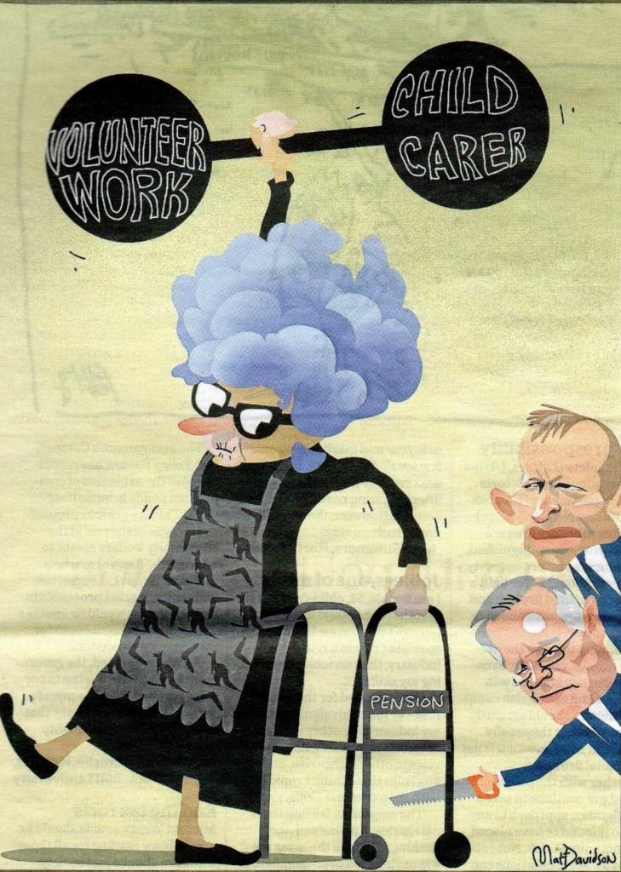

U3A Politics 2015 is about to begin, I look forward to another year of entertaining debate!

Terry Case.

